Software Requirements Specification (SRS)

dulichlientinh24H.com – Interprovincial Car Booking Platform
4/2026
Prepared by Nguyen Ngoc Tuan

Table of content
I. Introduction. 3
1. Project Overview. 3
2. Business Context. 3
3. Scope. 4
II. Overall Description. 4
1. Product Perspective. 4
2. Product Functions. 4
3. User Classes. 5
III. System Architecture Overview. 5
IV. Business Process (BPMN). 5
1. Process Overview. 5
2. Key Characteristic. 6
3. BPMN Diagram. 7
V. Functional Requirements. 8
1. Customer Features. 8
2. Admin Features. 8
3. Authentication. 9
VI. Non-Functional Requirements. 9
VII. User Stories & Acceptance Criteria. 10
VIII. Data Model. 13

I. Introduction.

1. Project Overview.
This project was developed in collaboration with a real client, a local transportation business named Nhựt Trường Interprovincial Car Service, which specializes in long-distance vehicle rental services across provinces in Vietnam.
The primary objective of the project is to design and implement a modern web platform that enables the business to:
- Expand its market reach beyond social media channels
- Provide transparent pricing information to customers
- Facilitate quick and convenient customer contact
Unlike traditional booking systems, the platform adopts an Online-to-Offline (O2O) model, where the website serves as a discovery and pricing interface, while actual booking transactions are completed externally via Zalo.

2. Business Context.
Prior to this project, the client relied heavily on platforms such as Facebook and TikTok for service promotion. While effective for marketing, these channels presented several limitations:
- Lack of structured pricing information
- Difficulty in managing large sets of route data
- Limited brand credibility due to absence of an official website
Recognizing these challenges, the client initiated this project with the goal of building a centralized digital platform to:
- Improve brand visibility
- Increase customer trust
- Streamline service information management

3. Scope.
The system focuses on:
- Vehicle route discovery and filtering
- Pricing transparency
- Admin data management
Out of scope:
- Online payment processing
- Internal booking/reservation management
Instead, the system follows an O2O (Online-to-Offline) model, where booking is completed via Zalo.

II. Overall Description.

1. Product Perspective.
The system is a hybrid web application:
- Frontend: Next.js
- Backend: Supabase (database)
- Domain: Godady.com (dulichlientinh24H.com
- External integration: Zalo (manual booking handling)

2. Product Functions.
Customer:
- Search routes
- Filter by price/location/type
- View pricing
- Contact admin via Zalo
Admin:
- Manage system data (CRUD)
- Import bulk data via Excel
- Manage authentication

3. User Classes.
User | Description
Customer | Public user browsing and searching routes
Admin | Authorized user managing system data

III. System Architecture Overview.
The system follows a hybrid architecture:
- Public data is fetched directly from Supabase (client-side)
- Sensitive operations (authentication) go through server-side API
Key Design Decisions:
- Use of in-memory filtering for instant UX
- Offloading booking to Zalo to reduce system complexity

IV. Business Process (BPMN).

1. Process Overview.
The booking process is modeled as an O2O workflow, where:
- User searches for routes
- System retrieves and filters data
- User views results
- Booking is initiated externally via Zalo

2. Key Characteristic.
- No internal transaction handling
- No booking persistence
- External communication via Zalo
This reduces system complexity and development cost while maintaining operational flexibility.

3. BPMN Diagram.
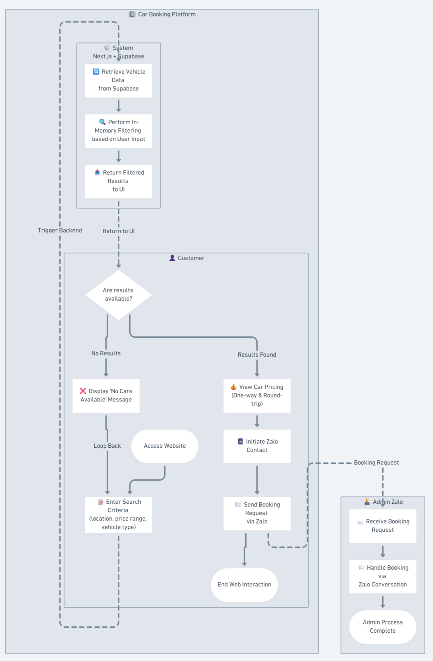

V. Functional Requirements.

1. Customer Features.
FR1: Search and Filter
- The system shall allow users to search routes by:
  - Departure location
  - Destination
  - Price range
  - Vehicle type
FR2: Display Results
- The system shall display:
  - One-way price
  - Round-trip price
FR3: Zalo Redirection
- The system shall allow users to initiate booking via Zalo

2. Admin Features.
FR4: Data Management (CRUD)
Admin shall be able to:
- Manage car types
- Manage routes
- Manage posts
- Manage featured locations
FR5: Bulk Import via Excel
- Admin shall upload .xls/.xlsx files
- System shall parse and insert data
Validation Rules:
- Must have exactly 6 columns
- Required fields cannot be empty
- Price must be numeric
- At least one price > 0
FR6: Duplicate Prevention
- System shall prevent duplicate routes based on: province + end_location + car_type

3. Authentication.
FR7: Admin Login
- Admin shall log in using password authentication
FR8: Change Password
- Admin shall update password securely

VI. Non-Functional Requirements.
Performance
- Filtering must be instant (client-side)
- No repeated API calls for search

Security
- Passwords must be hashed using bcrypt (salt rounds = 10)
- Authentication handled server-side

Usability
- UI must provide clear feedback:
  - Loading states
  - Error messages
  - Empty states

Scalability
- Separation of data and logic allows easy expansion
- Can later integrate payment system if needed

VII. User Stories & Acceptance Criteria.
EPIC 1: Customer Search & Filtering
User Story
As a customer,
I want to search and filter car routes by location and price,
so that I can quickly find suitable travel options.
Key Acceptance Criteria
- Filtering must be performed client-side (in-memory)
- Search must match:
  - province OR end_location (case-insensitive)
- Price filtering must use:
  - Minimum value between price_1 and price_2
- No additional API calls after initial load

EPIC 2: Pricing Visualization
User Story
As a customer,
I want to view detailed pricing information,
so that I can compare travel options effectively.
Key Acceptance Criteria
- System must display:
  - One-way price (price_1)
  - Round-trip price (price_2)
- UI must clearly distinguish pricing types
- Handle empty data:
  - “No data available”
  - “No matching results”

EPIC 3: External Booking (Zalo O2O)
User Story
As a customer,
I want to contact the admin via Zalo,
so that I can complete my booking outside the system.
Key Acceptance Criteria
- System must redirect or trigger Zalo contact
- Booking request must include:
  - Selected route info (optional enhancement)
- No internal booking state is stored
- Interaction ends on web after Zalo initiation

EPIC 4: Admin Data Management
User Story
As an admin,
I want to manage vehicle and route data,
so that the system information remains accurate and up to date.
Key Acceptance Criteria
- Admin can CRUD:
  - Car types
  - Routes
  - Posts
  - Featured locations
- Bulk import via Excel:
  - Validate structure (6 columns)
  - Support skip invalid rows
- Duplicate prevention:
province + end_location + car_type

EPIC 5: Authentication & Security
User Story
As an admin,
I want secure authentication,
so that only authorized users can access the system.
Key Acceptance Criteria
- Password must be hashed using bcrypt (salt rounds = 10)
- Login validation:
  - 400: Missing password
  - 401: Incorrect password
  - 404: Admin not found
- Change password:
  - Validate old password
  - Confirm new password match

VIII. Data Model.
